05/12/2022

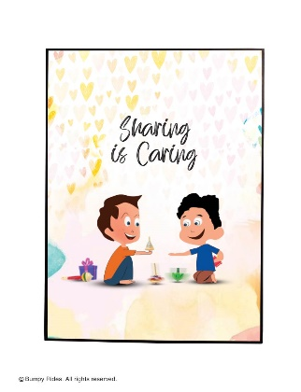

**Song of the week**:

‘I’ll be there for you’ – The Rembrandts

[I'll be there for you - The Rembrandts - Friends song lyrics - YouTube](https://www.youtube.com/watch?v=y_k681IUS0M)

**Theme of the week**:

‘Sharing’

**Quote of the week**:

‘Sharing is caring ’

**Mindful Monday**:

Listen to song and introduce ‘Sharing’ theme.

* Talk about sharing in class, home and with friends and how this can stretch to other things like sharing with those that may be less fortunate.

**Wellbeing Wednesday**:

Repeat song.

KS1 Input

[Sesame Street: Sharing Song! - YouTube](https://www.youtube.com/watch?v=ewhwY5-EP38)

KS1 & KS2 Activity

* See attached: Sharing Grinch activity from Picture News

**Fab Friday**:

Repeat song and invite class to dance along!

Mindful colouring

