14/11/2022

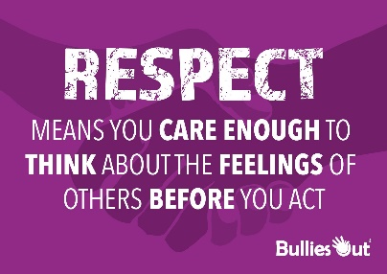

**Song of the week**:

‘Respect’ – Aretha Franklin

<https://www.youtube.com/watch?v=A134hShx_gw>

**Theme of the week**:

‘Be Respectful’ – Anti Bullying Week

**Quote of the week**:

‘Respect means you care enough to think about the feelings of others before you act.’

**Wellbeing Wednesday**:

Continue with theme and repeat song.

Input

Discuss the meaning of being respectful.

Check in with how the children are getting on with the kindness challenge.

Activity

Choose either or both:

* Who can I talk to activity sheet
* Kindness Jar activity sheet

**Mindful Monday**:

Listen to song, introduce the theme and quote.

Catch up with the children.

Anti-bullying PowerPoint. (See attached)

Introduce 7-day kindness challenge. (See attached)

**Fab Friday**:

Repeat song

* Discuss when the children have been respectful this week.
* How have the children got on with the 7-day kindness challenge

Mindful colouring (See attached anti bullying colouring sheets).

