31/10/2022

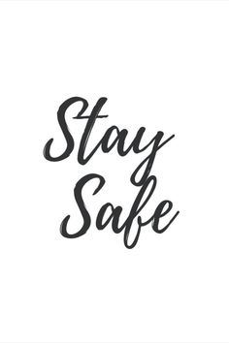

**Song of the week**:

‘Firework’ – Katy Perry

<https://www.youtube.com/watch?v=KSbwHzlcgs8>

**Theme of the week**:

‘Be Safe’

**Quote of the week**:

‘Stay Safe’

**Mindful Monday**:

On Tuesday:

Listen to song

Catch up with the children about half term.

**Wellbeing Wednesday**:

Continue with theme and repeat song.

EYFS/ KS1

Follow link for fireman Sam safety brief

<https://www.youtube.com/watch?v=JTqb8JLgiew>

KS2 Activity

Follow link for Twinkl firework safety brief

<https://www.youtube.com/watch?v=Q-fizT5O4ik>

**Fab Friday**:

Repeat song and invite class to dance along, remind of firework safety

* Discuss bonfire night and how exciting it is but the importance of being safe
* Remind to only attending safe bonfires and follow adults instructions with where to stand and if handling sparklers.
* Explain the difference between safe and unsafe firework displays



**Be Safe around fireworks**