17/10/2022

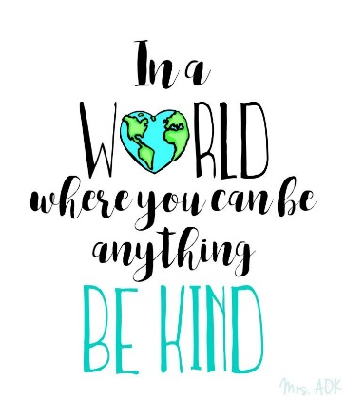

**Song of the week**:

Count on me- Bruno Mars

<https://www.youtube.com/watch?v=HSK2tDTSkWw>

**Theme of the week**:

‘Kindness’

**Quote of the week**:

‘In a world where you can be anything, be kind.’

**Mindful Monday**:

Listen to the song.

* Try to listen to the song daily
* Discuss which emotions the song provokes

Introduce ‘Kindness’ poem.

* Explore the emotion poem.
* Discuss what kindness means.
* Remind the children to be kind to themselves and others.

**Wellbeing Wednesday**:

Input

* Discuss the importance of being kind to yourself and others.
* Discuss what kind things children have done for themselves, for others or someone has done for them.

Activity

* Fill a cup with kindness activity (see attached).
* There is also a kindness checklist activity, which could be used as inspiration.

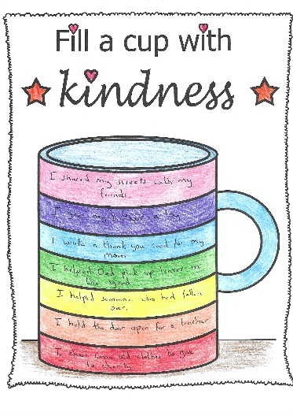

**Fab Friday**:

Mindful colouring

* Discuss any emotional barriers that children may have faced this week.
* Discuss how we overcame the barriers and how we became more resilient.
* Ask children to give examples of positive experiences that have happened this week or throughout the half term. **Positive reflections on the half term.**

