10/10/2022

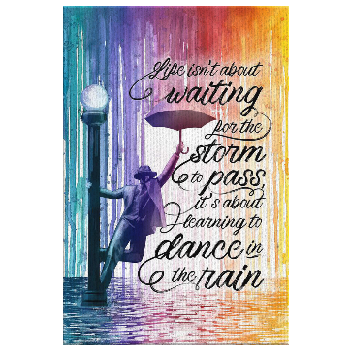

**Song of the week**:

‘Here comes the sun- The Beatles

<https://www.youtube.com/watch?v=fKLV8GCrveQ>

**Theme of the week**:

‘Tranquillity’ – Hello Yellow Day

**Quote of the week**:

‘Life isn’t about waiting for the

storm to pass, it’s about learning

to dance in the rain.’

**Mindful Monday**:

Listen to the song.

* Try to listen to the song daily
* Discuss which emotions the song provokes

Hello Yellow Day

* Children to wear yellow/ bright colours
* Discuss what hello yellow day is
* We will take a sunshine photo in the hall

Activity

* Hello Yellow Day challenge: for each challenge, the children get 2hps. This can be redeemed once then they can do good deeds and feel good about that!
* Challenge the children to do something nice for themselves this week. This could be the Wellbeing Bingo. This could be taken home to try at home.

**Wellbeing Wednesday**:

Introduce ‘Tranquillity’ poem.

* Explore the emotion poem.
* Discuss what tranquillity means.
* Talk about how we also need to look after our minds as well as our bodies
* Encourage class to think of what calms them.

Activity

* Mindful Colouring with calming music

**Fab Friday**:

* Discuss any emotional barriers that children may have faced this week.
* Discuss how we overcame the barriers and how we became more resilient.
* Ask children to give examples of positive experiences that have happened this week or things they have done for themselves.

