03/10/2022

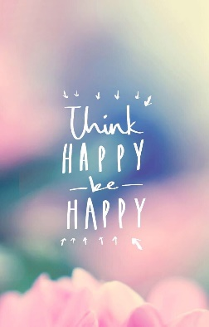

**Song of the week**:

‘Happy’ – Pharrell Williams

<https://www.youtube.com/watch?v=7E5_TpWgXf8>

‘I’m Walking on Sunshine’ – Katrina and the Waves

[Katrina And The Waves - Walking On Sunshine (Lyrics) - YouTube](https://www.youtube.com/watch?v=qK5KhQG06xU)

**Theme of the week**:

‘Happiness’

**Quote of the week**:

‘Think Happy, Be Happy’

**Mindful Monday**:

Listen to song and introduce ‘Happiness’ poem.

* Discuss which emotions the song provokes
* Explore the emotion poem and how happiness effects us and what things make us happy

**Wellbeing Wednesday**:

Continue with poem and repeat song.

* Share as a group things that make us happy.
* Discuss how happiness comes from lots of different things, exercise, hobbies or seeing other people happy.

KS1 & KS2 Activity

* Hand out post it notes or paper and ask children to make notes of 3 things in school that make them happy and 3 things outside of school.
* Share as a whole class or in small groups

**Fab Friday**:

Repeat song and invite class to dance along

