12/09/2022

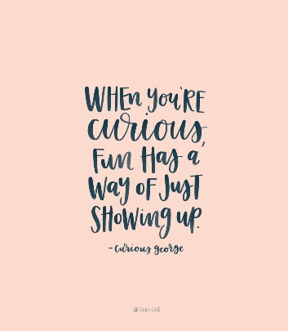

**Song of the week**:

‘Upside down’- Jack Johnson

<https://www.youtube.com/watch?v=dqUdI4AIDF0>

‘U

**Theme of the week**:

‘Curiosity’

**Quote of the week**:

‘When you’re curious, fun has a

way of just showing up’

**Wellbeing Wednesday**:

Continue with An Emotional Menagerie’ book and repeat song.

EYFS/ KS1 / KS2 Activity

Follow the link below for a short film about curiosity and resilience leading to wonderful things.

<https://www.youtube.com/watch?v=eDkpVwrhYfo>

**Mindful Monday**:

Introduce song

* Discuss the meaning of the word ‘Curious’
* Read the ‘curious’ poem from the ‘Emotional Menagerie’.

**Fab Friday**:

Continue with An Emotional Menagerie’ book and repeat song.

KS2 Activity

Ask class to name certain topics or questions in which they are curious about. As a class search these questions to find the answers.

