Hi everyone
I hope you are all keeping well, working hard and enjoying the weather!
As Easter is approaching, I thought it might be fun to do an Easter Design Technology challenge.
Your challenge is to take part in Charles Darwin’s Big Easter Egg Drop!
The idea is to create a container and parachute using materials from around the house that will allow you to drop a hollow Easter egg from a height and see if it lands safely without cracking the chocolate.
Design criteria:
You must only materials from around your house for the container and parachute such as old clothes or cloths, string, boxes, cartons, plastic containers, tissue paper or newspaper. You can join the materials with Sellotape or other types or tape or glue.
Here are some instructions to help you:
- Collect recycling materials to make a type of container to protect the egg from a high fall.
- Build your container and place a hollow chocolate egg inside.
- Select material to build a parachute.
- Cut a square of material and attach string or twine to all four corners.
- Attach the four ends of sting to your container so your container hangs under your parachute.
- Drop the egg from someplace high such as the arm of a sofa or the top of a slide (be sure it is safe, and an adult is with you).
- After you drop it look and see if your egg has cracked or remained intact.
- What was good about your design? What could you change to make it better?
- Take pictures of your DT challenge and upload them on your scrapbook or stick them in your home learning book

Some of the year 3 children have already been having a go at this challenge:

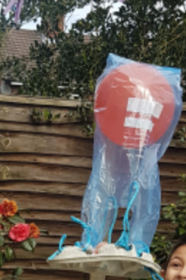
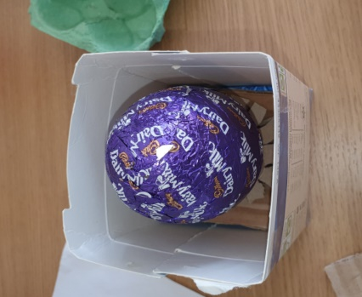
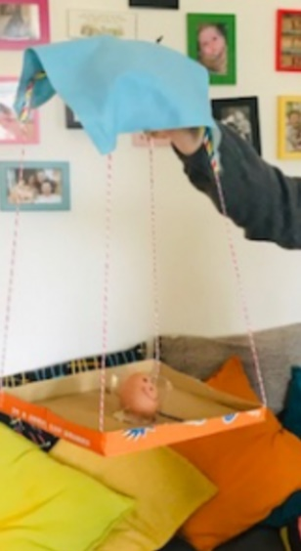
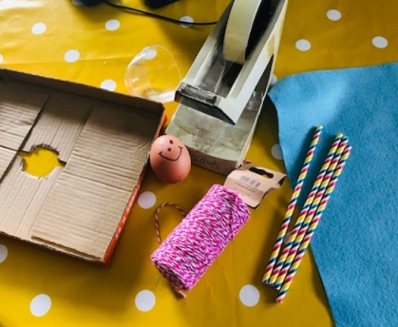

Let the challenge begin!

