**Competition Time!**

Calling all **green** fingered children!

As part of the Summer Fair this year, FOTSA are organising a miniature garden competition!

**HOW DOES**

**IT WORK?**

* Buy your seed tray from a member of FOTSA at the Tuck Shop or from the School Office.
* Each tray costs £1; this is your entry fee to the competition.
* Your name will be stuck to the bottom of the seed tray and your entry listed.
* Think carefully about your design!
* Try to use some natural materials and plants.
* Use your imagination to come up with a creative theme to your garden.
* PRIZE OF A £15 VOUCHER TO BE AWARDED TO THE WINNER!

BUT…

Most of all

have fun

getting

creative!!!!!!

TRAYS TO BE RETURNED TO FOTSA ON FRIDAY 28TH DURING THE SCHOOL DAY

OR AT THE FAIR ON SATURDAY 29TH JUNE (BEFORE 2:30PM)

**[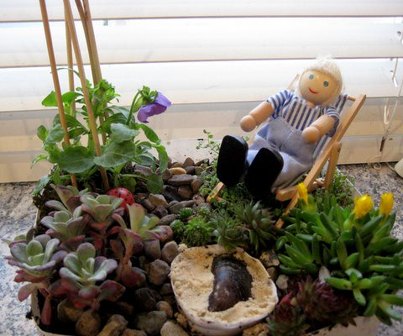](https://www.flickr.com/photos/46927993@N08/5786460071/)**