Developing Personal Confidence
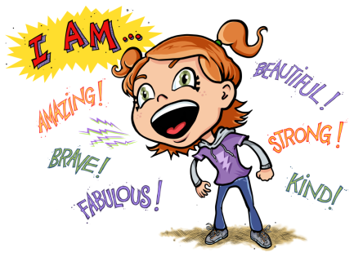
A Family Learning Course at
Charles Darwin School
A six week course for parents that is fun, friendly and free!
What does this course cover?

- Confidence – what is it?
- Looking at confidence in adults and children
- Effective communication – in different social situations
- Stress and how to manage it
- A certificate on completion of course

Please note: So that we can offer this course free of charge, you will be required to complete some paperwork.
This course will run for 6 weeks on Thursday mornings, 9-11am
Start Date: 06/06/19 Finish Date: 11/07/19
If you would like a place, please complete the form below and return to school

Yes, I will be coming to the ‘Developing Personal Confidence’ course.

Name: ________________________Contact Number__________________
I will need a crèche place for _________________________________

