Family First Aid
At Charles Darwin School
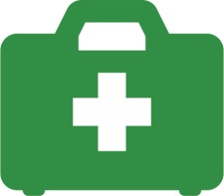
Would you like to learn emergency life- saving skills including CPR for adults and children (including babies)?

Would you know what to do if your child started choking? Or bleeding? Or how you would treat a burn?
Would you like to find out more about how to keep your family safe and well?

Our Family First Aid course covers all the basics that can help you to protect your family.
It is a FREE course and runs for 2 hours a week for 5 weeks on Thursday mornings, 9-11am
Start: 25/04/19 Finish: 16/05/19
This course is free and open to all parents and carers
There will be a crèche for your little ones
Please note: So that we can offer this course free of charge, you will be required to complete some paperwork. This course is NOT accredited but you will receive a certificate on completion.
If you would like a place, please complete the form below and return to school.
Yes, I will be coming to the ‘Family First Aid’ course.

Name: __________________I will need a crèche place for:______________

