03/07/2023

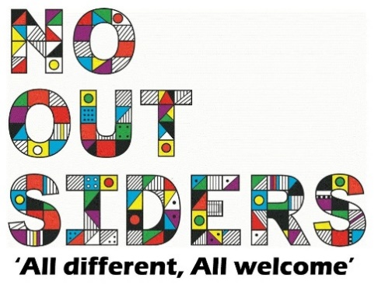

**Song of the week**:

Seasons of love rent-

<https://www.youtube.com/watch?v=RJIlHuMLOkE>

**Theme of the week**:

‘I feel White…’

**Quote of the week**:

‘Honest it the best policy’

**Wellbeing Wednesday**:

Whole School

Try and spend around 15 mins outside reading.

Children to lay down on the grass eyes closed and teacher to read class book to children.

This could also be done as quiet reading time after lunch.

**Wellbeing Wednesday**:

Talk to your class at an age appropriate level regarding enjoying your innocence and childhood.

Please refer to appropriate language and actions for children of your year group age.

This can lead on to also discussing the importance of truth and honesty.

**Mindful Monday**:

.

Welcome class in with song, greet children at door using greeting options if possible.

This week’s theme is pride and ambition.

**Fab Friday**:

Enjoy song and have a fantastic weekend!

**WHITE**

**Simplicity**

**Clean**

**Innocence**

**Honest**