12/06/2023

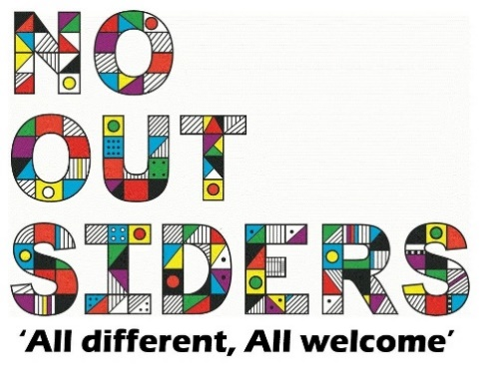

**Song of the week**:

Dance Monkey- Tones and I

<https://www.youtube.com/watch?v=1__CAdTJ5JU>

**Theme of the week**:

‘I feel Pink…’

**Quote of the week**:

PINK

Compassion  
Sincerity

Sweet

**Wellbeing Wednesday**:

Whole School

Try and spend around 15 mins outside reading.

Children to lay down on the grass eyes closed and teacher to read class book to children.

This could also be done as quiet reading time after lunch.

**Wellbeing Wednesday**:

Pet Challenge  
Create a pet rock, choose a stone from outside, decorate and name. Keep it safe all week.

(can also be done with boiled eggs if you would like to make the challenge harder)

**Mindful Monday**:

.

Welcome class in with song, greet children at door using greeting options if possible.

This weeks theme is compassion, showing compassion and how to care for things.

**Fab Friday**:

Enjoy song and have a fantastic weekend!

PINK

Sweet

Sincerity

Compassion

Sophistication

Bright