22/05/2023

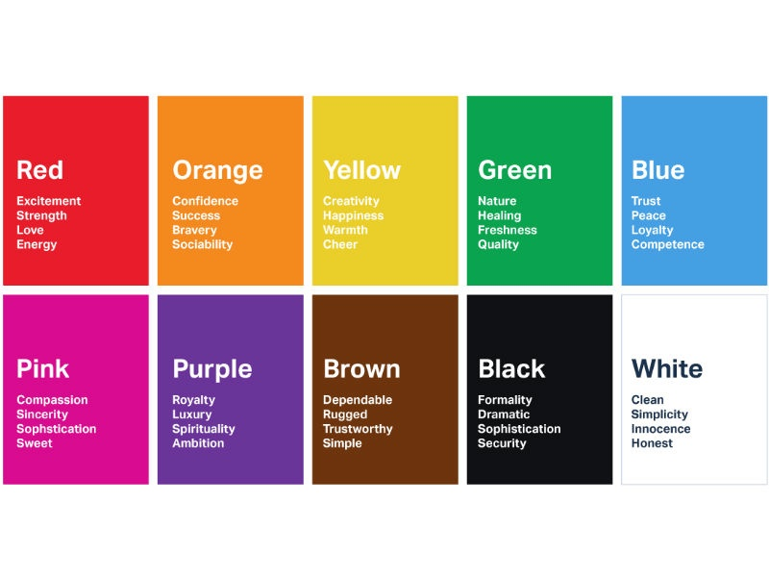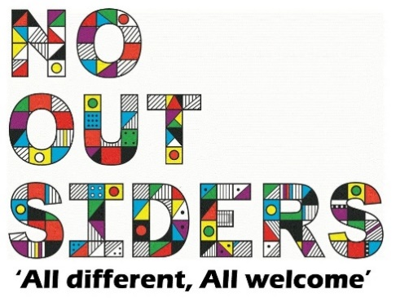

**Song of the week**:

Livin on a prayer- Bon Jovi

[https://www.youtube.com/watch?v=ohFtQIPqGSo](https://www.youtube.com/watch?v=ohFtQIPqGSo" \t "_blank)

**Theme of the week**:

‘I feel Blue…’

**Quote of the week**:

BLUE

Trust  
Loyalty  
Peace

**Wellbeing Wednesday**:

EYFS/KS1  
Create posters to encourage your house point team on sports day

KS2  
As a class play the count to 20 game. Only one person can say one number at a time, see how far you can get with 20 being the goal.   
*This is to encourage working as a team and celebrating each other’s success and taking failure as a team too.*

**Mindful Monday**:

.

Welcome class in with song, greet children at door using greeting options if possible.

We are focusing on building confidence and sportsmanship in preparation for Thursdays sports day

**Fab Friday**:

Enjoy song and have a fantastic half term!

BLUE

Trust

Peace

Loyalty

Support