15/05/2023

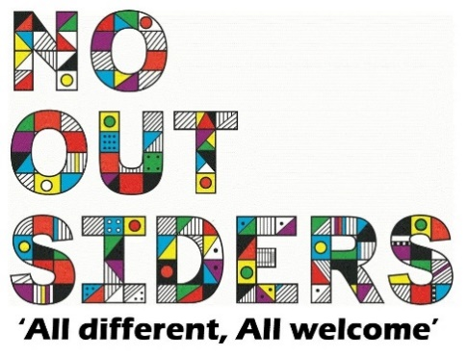

**Song of the week**:

What a wonderful world- Changing lives Choir

<https://www.youtube.com/watch?v=ddLd0QRf7Vg>

What a wonderful world- Louis Armstrong

<https://www.youtube.com/watch?v=p-T6aaRV9HY>

**Theme of the week**:

‘I feel Green…’

**Quote of the week**:

GREEN,

Nature  
Healing

Freshness

**Wellbeing Wednesday**:

Whole School

Try and spend around 15 mins outside reading.

Children to lay down on the grass eyes closed and teacher to read class book to children.

This could also be done as quiet reading time after lunch.

**Mindful Monday**:

.

Welcome class in with song, greet children at door using greeting options if possible.

This week’s theme is concentrating on using nature and fresh air to calm ourselves and clear our heads.

**Fab Friday**:

Enjoy song and have a fantastic weekend!

GREEN

Nature

Healing

Freshness

Quality