24/04/2023

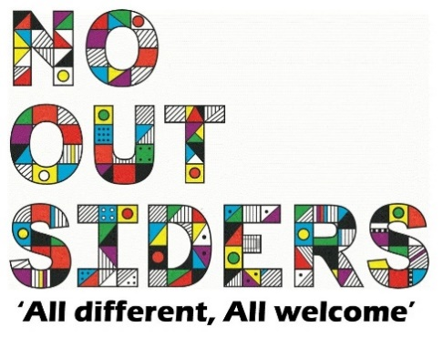

**Song of the week**:

Taylor Swift- Shake it off

<https://www.youtube.com/watch?v=8xG7mH8i-WE>

**Theme of the week**:

‘I feel Red…’

**Quote of the week**:

‘Red,

Excitement

Strength

Love, energy’

**Wellbeing Wednesday**:

Whole school activity-

See the sign language cards attached-

This can be done as an entire class or work in pairs.

Try and memorize the BSL for each emotion.

**Mindful Monday**:

.

Welcome class in with song, greet children at door using greeting options if possible.

**Fab Friday**:

Enjoy song and have a fantastic weekend!

RED

Excitement

Strength

Love

Energy