27/03/2023

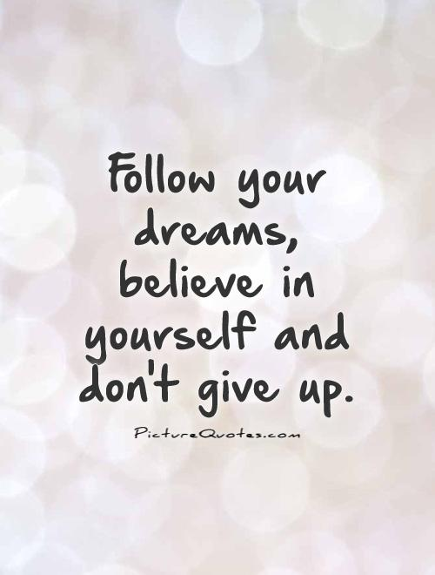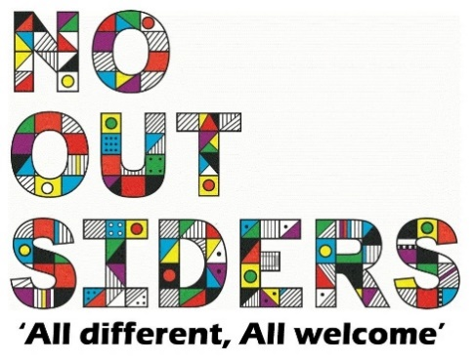

**Song of the week**:

Don’t’ stop believing- Glee

[Don't stop believing Glee • lyrics •](https://www.youtube.com/watch?v=iiFKju-2UDc)

**Theme of the week**:

‘I Believe’

**Quote of the week**:

‘’Follow your dreams,   
Believe in yourself and don’t

Give up’’

**Wellbeing Wednesday**:

EYFS/KS1

Powerpoint attached

KS2  
Write a letter to yourself, telling yourself your favourite things about you.   
You do not have to share this letter with anybody unless you want to.

**Mindful Monday**:

.

EYFS/KS1- Introduce song and theme

KS2 Powerpoint attached.

**Fab Friday**:

Enjoy song

