20/03/2023

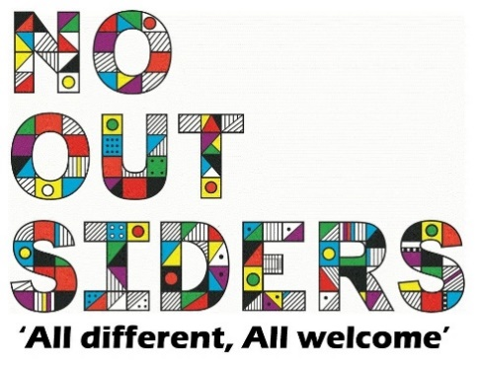

**Song of the week**:

‘Don’t Worry Be Happy’ by Bobby McFerrin Bobby McFerrin - Don't Worry Be Happy (Lyrics)

**Theme of the week**:

‘worries’

**Quote of the week**:

‘’Worrying is like walking around

With an umbrella waiting

For it to rain’’

**Wellbeing Wednesday**:

Whole School Book- ‘There’s a bully inside my brain’

Book can be found on youtube, ‘there’s a bully inside my brain’, to be played to class.

Open to questions at the end.

Class worry jar/box

Have a box/jar in classroom with postit notes and pens, children can put worries on paper and put them in the jar- a problem shared is a problem halved.

**Mindful Monday**:

.

Introduce song and theme to class.

**Fab Friday**:

Enjoy song,

If class want to share worries they added to the jar then discuss how we can work past those worries.

