13/03/2023

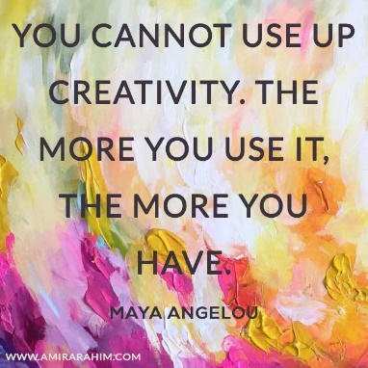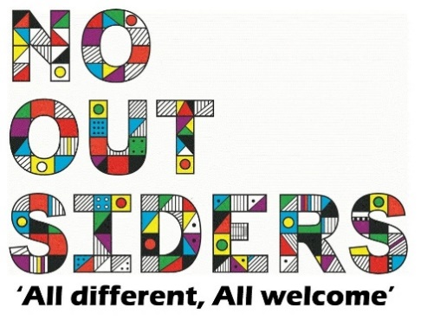

**Song of the week**:

Imagine Dragons - On Top Of The World

<https://www.youtube.com/watch?v=g--BAaaRKLA>

**Theme of the week**:

‘Creativity’

**Quote of the week**:

‘You cannot use up creativity.

The more you use it, the more

you have’

**Wellbeing Wednesday**:

Repeat song.

See attached activity EYFS/ KS1 document

KS2 Acitvity

**DARWIN’S DRAGON DEN**

See attached document,

Work in teams or individually to create something new, can be an invention to help you with life for example- a back pack that turns into a car.

Draw invention and describe how you are going to make it.

Invite to pitch to rest of class.

**Mindful Monday**:

.

Introduce song and theme to class.

**Fab Friday**:

Repeat song and invite class to dance along

