06/03/2023

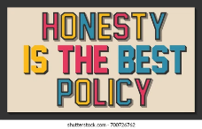=

**Song of the week**:

‘Honest’ – Shawn Mendes

https://www.youtube.com/watch?app=desktop&v=B2lkjLF2DaU

**Theme of the week**:

‘Honesty’

**Quote of the week**:

‘Honesty is the best policy.’

**Mindful Monday**:

Listen to song and introduce ‘Honest’ theme.

* Truthfulness and Honesty Powerpoint

**Wellbeing Wednesday**:

Repeat song.

EYFS/ KS1

* Social Stories

KS2

* Honesty activity sheet
* Honesty word search

**Fab Friday**:

Repeat song and invite class to dance along.

Mindful Colouring/ Yoga

