23/01/2023

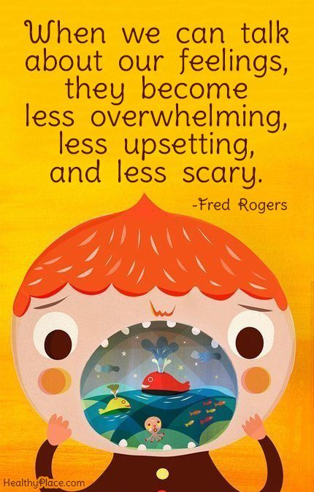

**Song of the week**:

‘The Call’ – Regina Spektor

<https://www.youtube.com/watch?v=oNsQewlFtEs>

**Theme of the week**:

‘Feelings’

**Quote of the week**:

‘When we talk about our feelings,

They become less overwhelming,

Less upsetting and less scary’

**Wellbeing Wednesday**:

Repeat song

KS1

Power point followed by feelings monster activity- attached

KS2

Power point followed by iceberg activity- attached

**Mindful Monday**:

Listen to song and introduce ‘Feeling’ theme.

This week is all about understanding how we feel and how to put it into words. This is an opportunity to expand emotional vocabulary.

**Fab Friday**:

Repeat song and invite class to dance along.

Please see below link for further support and resources for vulnerable children

<https://www.youngminds.org.uk/young-person/find-help/how-i-am-feeling/>

